Welcome to
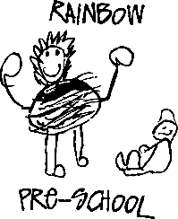

An information pack for parents & carers

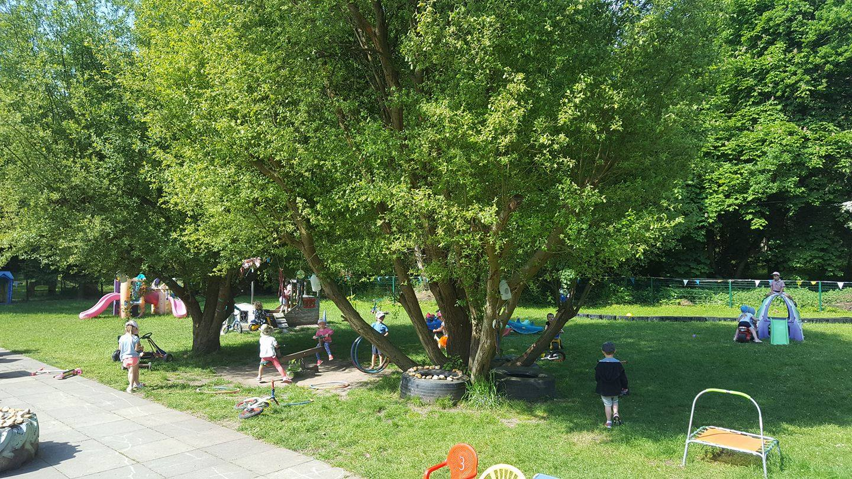
Welcome to Rainbow Pre-School.
The Pre-School staff understand how important your child is and it is our aim to deliver the highest quality of care and education to help them to achieve their best.
This prospectus aims to provide you with an introduction to Rainbow Pre-School, our routines, our approach to supporting your child’s learning and development and how we aim to work together with you to best meet your child’s individual needs. This should be read alongside our Childcare Terms and Conditions for a full description of our services.

Our setting aims to:
Provide high quality care and education for children below statutory school age
Work in partnership with parents to help children to learn and develop
Add to the life and well-being of the local community
Offer children and their parents a service that promotes equality and values diversity.

About us
The Pre-School was formed in 1968 by a small group of local parents to meet the needs of the Pre-School aged children in the village of Stoke Poges. The Pre-School operates from a scout building which is surrounded by an extensive secure garden area set within eight acres of private woodland.
The Pre-School is a registered charity and is managed by a voluntary parent committee who support the teaching staff. The committee relies on volunteers who are prepared to give some of their time to help with the running of the pre-school or who would like to be involved with fundraising activities. Fundraising events provide a valuable source of income for the Pre-School and we ensure these funds are used for purchasing new equipment and toys to improve the children’s experience at the pre-school. The events also provide a great opportunity to meet other parents away from the mêlée of drop off and collection times.

Contact Information
Contact No (school hours only): 01753 647572

Address
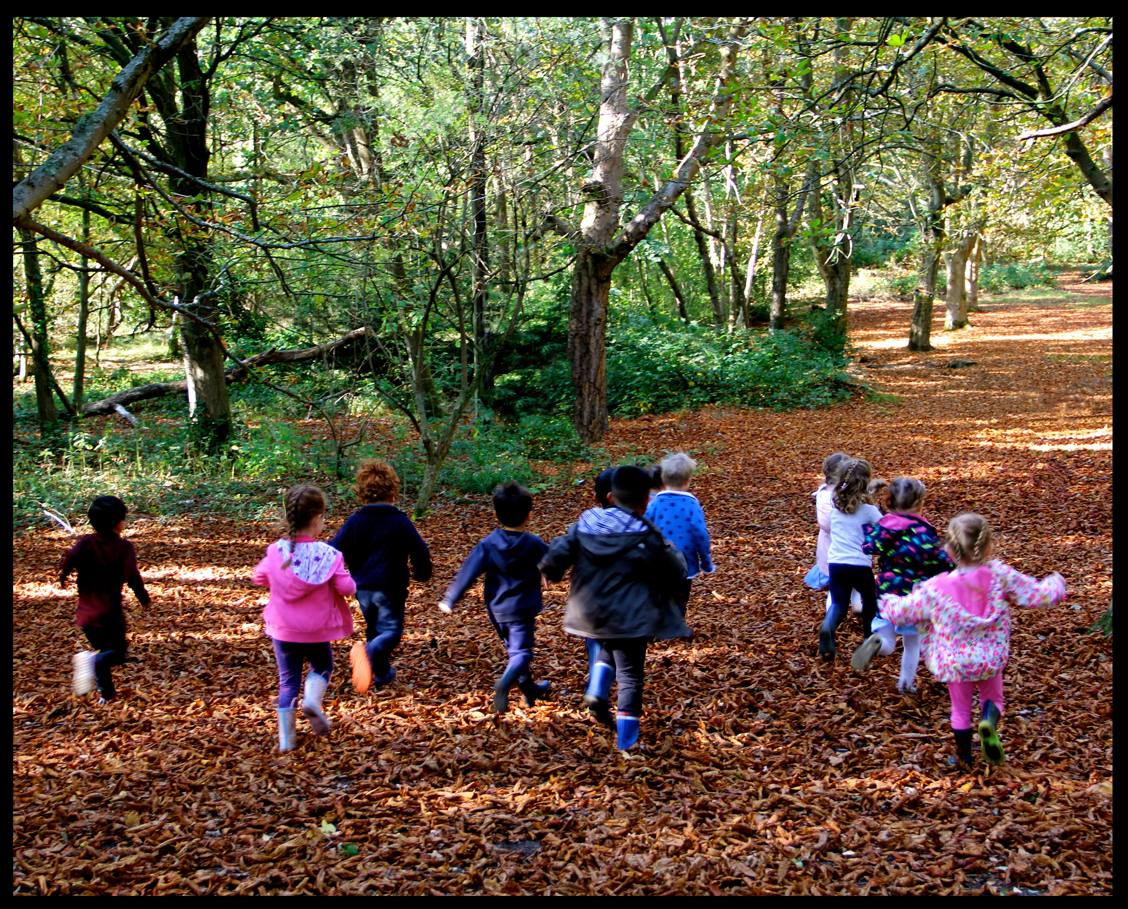
Bucks The Lair
The Walter Davies Scout Centre
Duffield Lane
Stoke Poges
Bucks SL2 4AL

Website
www.stokepogesrainbow.co.uk

Email
stokepogesrainbow@hotmail.co.uk

Reg. Charity No. 1008931

Ofsted Reg. No. EY252578

Member of the Pre-School Learning Alliance

Our staff team:  Name | Job Title | Qualifications and Experience
CARON RHODES | MANAGER | NNEB 25 YEARS EXPERIENCE
DAWN DRUMMOND | DEPUTY MANAGER | CACHE LEVEL 3 8 YEARS EXPERIENCE
PETAL RHODES | EARLY YEARS PRACTITIONER | CACHE LEVEL 2 6 YEARS EXPERIENCE

The staff are supported by maintenance personnel employed / engaged by our landlords (Ealing & Hanwell Scouts) to ensure the building remains safe for both the children and the staff. Wherever possible all maintenance jobs will be undertaken outside of the Pre-School hours.

Key person and your child
Our setting uses a key person approach. This means that each member of staff has a group of children for whom she/he is particularly responsible. Your child's key person will be the person who works with you to make sure that the childcare that we provide is right for your child's particular needs and interests. When your child first starts at the setting, she will help your child to settle and throughout your child's time at the setting, she will help your child to benefit from our activities.
Morning sessions 09:00 - 12:00 (Children aged 2 - 5)
Afternoon Sessions 13:00 - 15:00 (Children aged 2 -5)
All Day Sessions 09:00 - 15:00 (children aged 2 -5)

The hourly charge is currently £6.50. The cost of the snack is 50p per session to be paid in advance and will be included on your half termly fee invoice.

We currently offer government funding for 2, 3 and 4 year old’s.

Government Funding For Early Years Education
Children are eligible for Government funding from the term following their third birthday. Funding covers 15 hours per week, minimum 3 hours per day, for the full academic year of 38 weeks. Some parents may be eligible for an additional 15 hours of extended funding depending on their personal circumstances. When your child becomes eligible, you will automatically receive a form regarding their entitlement from the Pre-School staff. You will also need to provide details of any other setting that your child attends. In line with Government requirements, we will need to see an original copy of your child’s birth certificate or passport. Once you have returned the form to us, you need do nothing more – the claim will be made for you. At the end of each term the Manager will contact you to check if you wish to make any changes to the hours your child attends the Pre-School.

Any sessions not covered by the Government scheme will be billed at the usual rate £6.50 per hour. Ad-hoc sessions may also available, please speak to staff member.
Children in receipt of government funding will be charged a sessional fee of £3:50 to cover consumables and snacks. A session is either a morning or an afternoon. All fees to be paid in advance and will be included on your half termly fee invoice.

We ask that all children are registered for a minimum of 2 sessions per week – this is to ensure that the children have a chance to settle into the routines, and gain some continuity in their familiarity, friendships and play. Once a child is registered on our waiting list, the parents and carers are informed when a place becomes available.

Fees are payable half termly in advance. Fees can be paid by cash or bank transfer.

Account name: Rainbow Pre-School, Stoke Poges
Account number: 65726002
Sort code: 08-92-99

Four weeks written notice is required if the child is to be removed from Preschool for whatever reason. Fees will be payable up until the end of the term if notice is not received. Fees are payable when the child is absent. If your child is to be absent for an extended period due to hospitalisation, please speak to a staff member. All cases are dealt with on a one-to-one basis.
Please note: that if you receive Child Tax Credits you may be entitled to claim some or all of your childcare costs back – to find out if you are eligible, call the HMRC helpline on 0345 300 3900, or look on the HMRC website. We also accept various employers’ childcare vouchers e.g. Sedexo – please ask for details.

Non-Payment of Fees
We understand that from time-to-time some people may have difficulty in paying bills. We ask all parents and carers in this position to contact the Manager as soon as possible, in complete confidence, before going into arrears.
Arrangements can usually be made for payment in instalments, either weekly or monthly, with prior agreement.

If a family has used the services provided by the Preschool without payment or their payment has been dishonoured, the Pre-School will adopt the following staged procedure:
- Issue an ‘Overdue Account’ letter asking for payment in full within seven days. If payment is received within seven days no further action will be taken.
- If payment is not received a ‘Second Overdue Account’ letter will be issued asking for immediate payment, in full within a further seven days plus a £10 administration fee. If payment is received within that seven day period no further action will be taken.
- If after fourteen days from the original “Overdue Account” letter, full payment or a payment plan agreed by the Pre-School’s Manager and Committee Chairperson, has not been received, a ‘Final Warning’ letter will be issued plus a further £10 administration fee. At this stage your child(ren) will be unable to use our services until payment in full is received. If payment is received within seven days of the “Final Overdue Account” letter, no further action will be taken.
- If payment is not received within seven days of the “Final Overdue Account” letter, the Preschool will immediately begin proceedings in the County Court for which we charge an administration fee of £50 and all court costs. If the Pre-School is required to attend at County Court, costs will be applied at a rate of £20 per hour.

The Preschool would like to make it known that at all times we are willing to find an appropriate solution to financial problems and always endeavour to solve them amicably. However, as a registered charity, we cannot afford to allow a bad debt situation to become prolonged, and as such must have a strict policy on non-payment.

Parents
You are regarded as members of our setting who have full participatory rights. These include a right to be:
- Valued and respected
- Kept informed
- Consulted
- Involved
- Included at all levels

As a voluntary managed setting, we also depend on the good will of parents and their involvement to keep going. Membership of the setting carries expectations on you for your support and commitment.

How parents take part in the setting
Our setting recognises parents as the first and most important educators of their children. All of the staff see themselves as partners with you in providing care and education for your child. There are many ways in which parents take part in making the setting a welcoming and stimulating place for children and parents, such as:
- exchanging knowledge about their children's needs, activities, interests and progress with the staff;
- helping at sessions of the setting;
- sharing their own special interests with the children;
- fundraising to provide equipment and materials used in the children's play activities;
- being part of the management of the setting;
- joining in community activities in which the setting takes part; and
- building friendships with other parents in the setting.

A number of activities will be held throughout the school year which will involve parent and child participation. We have found from previous experience that these events give a child great joy when a parent is involved. While we appreciate you may be pressed for time, please try to attend these activities when possible. Siblings, grandparents, carers and other family members are also welcome to join in

Tapestry builds a very special record of a child’s experiences, development and learning journey through your child’s time at the Pre-School and as they move through te reception year at school. Using photos, videos, and diary entries we can share the story of your child’s development: sharing their WOW moments. Celebrating your child’s unique journey. You as parents or carers are able to view your child’s progress, the activities provided for them, and how much fun they’re having, whilst also uploading your own comments. We really value the contributions you have to make

Starting at our setting
First days
We want your child to feel happy and safe with us. To ensure that your child has a successful transition into the pre-school our staff will work with you to decide on how to help your child to settle into the setting.
We hope that you and your child enjoy being members of our setting and that you both find taking part in our activities interesting and stimulating. Our staff team are always ready and willing to talk with you about your ideas, views or questions.

Children's development and learning
We aim to ensure that each child:
- Is in a safe and stimulating environment;
- Is given generous care and attention, because of our ratio of qualified staff to children, as well as volunteer helpers;
- Has the chance to join in with other children and adults to live, play, work and learn together;
- Is helped to take forward her/his learning and development by being helped to build on what she/he already knows and can do;
- Has a personal key person who makes sure each child makes satisfying progress;
- Is in a setting that sees parents as partners in helping each child to learn and develop; and
- Is in a setting in which parents help to shape the service it offers.

The Early Years Foundation Stage
Provision for the development and learning of children from birth to 5 years is guided by the Early Years Foundation Stage. Our provision reflects the four overarching principles of the Statutory Framework for the Early Years Foundation Stage (DfE 2020):

A Unique Child
Every child is a unique child who is constantly learning and can be resilient, capable, confident and self-assured.

Positive Relationships
Children learn to be strong and independent through positive relationships.

Enabling Environments
Children learn and develop well in enabling environments, in which their experiences respond to their individual needs and there is a strong partnership between practitioners, parents and carers.

Learning and Development
Children develop and learn in different ways and at different rates. The framework covers the education and care of all children in early years provision including children with special educational needs and disabilities. Children start to learn about the world around them from the moment they are born. The care and education offered by our setting helps children to continue to do this by providing all of the children with interesting activities that are appropriate for their age and stage of development.

The Areas of Development and Learning comprise:

Prime Areas  Personal, social and emotional development.  Physical development.  Communication and language. | Specific Areas  Literacy.  Mathematics.  Understanding the world.  Expressive arts and design.

Our approach to learning and development and assessment
Learning through play
Being active and playing supports young children’s learning and development through doing and talking. This is how children learn to think about and understand the world around them. We use the EYFS statutory guidance on education programmes to plan and provide opportunities which will help children to make progress in all areas of learning. This programme is made up of a mixture of activities that children plan and organise for themselves and activities planned and led by practitioners.

The setting's timetable and routines
Our setting believes that care and education are equally important in the experience which we offer children. The routines and activities that make up the day in our setting are provided in ways that:
- Help each child to feel that she/he is a valued member of the setting;
- Ensure the safety of each child;
- Help children to gain from the social experience of being part of a group; and
- Provide children with opportunities to learn and help them to value learning.

Policies
All our policies are available for review at any time, please ask a member of staff.

Absence / Sickness
Please advise staff as soon as possible if your child will not be able to attend. Our contact number is 01753 647572. We ask that you do not bring your child if they are unwell. We will refuse admittance if your child has a temperature, signs of Covid, sickness, diarrhoea or a contagious infection or disease. Further information is contained in our Policy documents which are available to view on our website or at the pre-school.

Late collection
We acknowledge the vast majority of parents/carers always pick up their children on time. The impact on a child of not being picked up from Pre-School on time cannot be underestimated. The child that has been left behind will feel an increasing level of anxiety and distress the longer that they are unsure of where their parents are. Clearly this is not a good thing to happen to any child.
There will be a charge of £2 per minute per child applied to contribute to the cost to the Pre-School for the supervision of the child. The charge will be issued by invoice the following day and will be required to be settled by the parent / carer within 48 hours, before further charges apply.

Accident Reporting
Preschool take all accidents and incidents seriously and report all bumps and grazes sustained during a session. Parents are notified of any accident on class Dojo and followed up by a phone call in necessary.
We also ask that if your child has sustained an injury outside of Preschool you inform a member of staff at drop off. Preschool staff will then be able to consider your child's condition when planning activities,

Confidentiality
The details of your child's time in Preschool will be kept confidential: you will always have access to your own child's files. Please ask a member of staff. Information that you give to staff will not be passed onto anyone else without permission. Parents and carers who volunteer are also asked to sign a confidentiality agreement.

Confidentiality Exception: Child Protection
We have a duty to inform social services of any significant concerns regarding the children in our care. We are a Preschool in which children are safe from abuse and in which any suspicion of abuse is promptly and appropriately responded to.

Forced Closure
On very rare occasions we may have to close Preschool for Health and Safety reasons, for example, if the water is cut off or during times of severe weather. In the event of severe weather, we will put out messages via Facebook, email, the website and text message

What to wear and bring to Preschool
Preschool activities can be messy and physical. Although we provide aprons please do not send your child in their 'best' clothes. Please leave a change of NAMED clothes in your child’s Rainbow tote bag. We currently are unable to stock spare clothes, so make sure you provide plenty if your child is toilet training.
Also please try to avoid difficult to undo clothing such as belts, popper vests and dungarees as this makes independent toileting far more difficult.

Uniform
We sell branded Preschool t-shirts and hoodies. Please ask a member of staff for details.

Wellies
Our garden area and surrounding woodland can be extremely boggy. It would be upsetting for your child not to be able to explore the outdoor environment due to unsuitable footwear. For this reason, we ask that your child arrives in a pair of named wellies and changes into a pair of soft shoes or slippers, which will be kept in their rainbow tote bag. In order the staff to promote and support your child’s self-help skills we ask that the shoes do not have laces.

Hot weather days
During the summer term please ensure your child has a sun hat and that application of long-lasting sun cream is applied before arrival even if there is only the slightest chance of sunshine! When the weather does get warm we will ask for a bottle of named sunscreen for your child, to ensure reapplication during the day.

Cold weather days
During winter months please dress your child in warm layers. Also, we do not let the weather prevent outdoor play – so please remember named hats and gloves.

Toy’s from home
We ask that children do not bring toys into Preschool, (other than comforters for settling in) this can cause upset if precious items are lost or broken.

Children in Pull-ups or nappies
We welcome all children from the age of two regardless of where they are with toileting. For reasons of hygiene we prefer not to have potties in Preschool. Staff will work closely with parents and carers to support toilet training if required. We are happy to accommodate the use of disposable or washable nappies. We ask that parents provide nappies/wipes etc. For their child throughout the toilet training process, and to continue to do so until toilet skills are fully mastered. All changes are recorded in our Health and Wellbeing folder and Class Dojo.

Children’s Packed Lunch Guidelines
Eating together can be a wonderful source of learning for children, and at Rainbow we aim to make our lunch times a positive experience.
When providing your child with a packed lunch, it can be a challenge to keep them interesting and healthy. About a third of our diet should be made up of starchy foods such as bread, so sandwiches are a good choice. The key to a healthy lunch box is to include a balance of appropriate foods from the four main food groups-:
- Breads and Cereals
- Fruit and Vegetables
- Meat or alternatives
- Milk and Dairy products or alternatives
Foods in the 5th group containing fat and sugar should be eaten in moderation.
Please put familiar foods prepared in their usual way in your child’s packed lunch. Pre-school lunch times are not a good time to introduce new foods to your child as it may be upsetting if they are hungry and don’t like the food they have been given. Please put in the amount of food you would normally expect your child to eat.

Allergies
Some children have dietary restrictions or allergies to certain foods, which should be made clear to the staff before entry to the Pre-School. By ensuring the staff team are aware of restrictions, we can prepare appropriate snacks for that child.
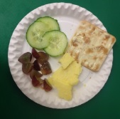

Please do NOT put items containing sesame seeds such as hummus and seeded breads, crustaceans, eggs, nuts or nut trace products such as peanut butter or chocolate spread in your child’s lunch box. We currently have children at the Pre-School who have severe allergies and nuts are a choking hazard for children under the age of 5 years. Thank you for your co-operation.

Bread, other cereals and potatoes group
Ideas: bread and bread rolls, bagels, pitta bread, french stick, crisp bread, crackers, pasta and rice salads.

Fruit and vegetable group
Ideas: salad in sandwiches and rolls, cherry tomatoes, apples, pears, satsuma’s, bananas, grapes, melon, plums, nectarines, dried fruit, dish of fruit salad, fruit smoothies and fruit juices.

Meat, fish and alternatives group
Ideas: slices of ham, chicken, turkey, canned tuna, salmon, cheese and Tofu pieces.
Drinks
Your child will be offered the choice of water or milk to accompany their lunch.

Too much Food
The stomach of a child between the age of 2 & 6 is approximately the size of their fist and has a capacity of 500ml, an adult’s stomach is more than 3 times the size and has a capacity of 1500ml plus. Please provide your child with an age-appropriate sized lunch, sending too much food in your child’s lunchbox will result in food waste, may encourage overeating and simply may overwhelm your child.

Sweets and chocolate bars will be returned in your child’s lunch box.

We recommend that you include an ice pack in your child’s lunch box to keep all food at the optimal temperature Please ensure that your child’s lunchbox is emptied and sanitised on a daily basis.

During each session each child will be provided with a healthy snack containing fruit and vegetables. The snacks are provided on a rolling rota to ensure the children receive a variety of snacks.
Serving Snack:
Children will be provided with individual servings.
Age appropriate portions will be served at all times.
Milk / milk alternative and water will be offered.
Uneaten food will be discarded.

Self help skills:
Children wash their hands.
Unless specifically requested by the parent / carer, children will drink from a beaker.
Children are encouraged to use the appropriate eating utensils.
Children are encouraged to pour their own drinks.

Food Preparation
Due to the increased awareness of food-borne illnesses and the importance of good hygiene, each member of staff has completed a food hygiene qualification.
All fruits and vegetables must be washed thoroughly at the pre-school.
Hands must be washed before preparing and serving food.
Rubbish is removed at the end of each session.

Birthday / Festival Celebrations
We enjoy celebrating special times with your child. If you wish to provide a snack / cake either shop bought or homemade for all to share, please provide the original packaging or ingredient list to enable the staff to check for allergens.

Fundraising
We rely on volunteers to help with our fundraising to help Preschool afford to buy better resources to make your child’s Preschool experience even more special. Please let us know if you can help in anyway however big or small it may be!

Committee
We hold our Annual General Meeting during the autumn term of the school year. We strongly urge all families to attend this as it informs the planning for the upcoming year, regardless of whether you intend to stand for the committee or not.
Committee meetings are held every six weeks either in person or via Zoom and the minutes are available from staff.
The main roles on the committee are: Chair, Secretary and Treasurer, there is also a fundraising subcommittee. The committee ensures that the business side of Preschool runs smoothly, ensuring all policies and procedures are adequate and adhered to.

Complaints Procedure
We aim to always provide the highest quality education and care for all the children. Our intention is to work in partnership with families and the community and we welcome suggestions on how to improve our service at any time.

Withdrawing an offer of a place
Any offers of a place found to be made on the basis of inaccurate information can be withdrawn. Such examples would include fraudulent applications, intentionally misleading applications, a false claim to citizenship and the failure of a parent to respond to an offer of a place within a reasonable amount of time.

Termination of a contract
Please refer to the settings terms and conditions

If you have any questions, please speak to a member of staff who will be happy to help you

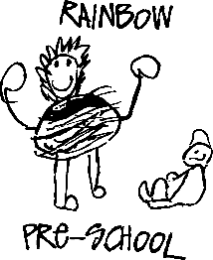

The Walter Davies Scouting Centre, Duffield Lane, Stoke Poges, Bucks SL2 4AL
Tel: 01753 647572 Email: stokepogesrainbow@hotmail.co.uk

You are required to provide us with at least one month’s notice of withdrawing your child. If insufficient notice is given you will be responsible for the full fees for your child for one month from the date of notice. Please refer to our terms and conditions for full details.

A final invoice will be issued reflecting the fees chargeable for the remaining period that your child attends - together with any previously invoiced amounts which remain outstanding.

I confirm that _______________________________________________will be leaving Rainbow Pre-school

on _______________________________________ and hereby give the required one month’s notice period.

Name of Parent / Guardian ________________________________________________________________

Signed ___________________________________________________ Date ________________________

Because we are always seeking to develop and improve our services we would be grateful for a response to the questions below. All feedback is treated confidentially and is greatly valued.
1. How long has your child attended our setting? |  | Years |  | Months

2. Which age group does your child attend? | 2-3’s / 3-5’s

3. Why is your child leaving? |  | Cost |  | Starting school |  | Attending another setting

Other

4. How would you rate the standard of care and education your child has received? |  | Very good |  | Good |  | Satisfactory |  | Poor

